**BLOOD TRANSFUSSION**

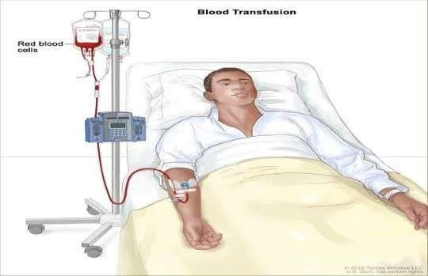SATYA DEVI BOHARA

RUBY YADAV

# DEFINITION

A Blood transfusion is the infusion of whole blood or blood components such as plasma, RBCs, or platelets into the venous system.

# PURPOSES

To increase blood volume after surgery, trauma, or hemorrhage.

To increase the number of red blood cells in a patient with severe chronic anemia.

To provide platelets to patients with low platelet counts due to treatment with chemotherapy.

To provide clotting factors in plasma for patients with hemophilia or disseminated intravascular coagulopathy ( DIC ).

To replace plasma proteins such as albumin.

To replace fresh frozen plasma in case of DIC.

# INDICATIONS

➢Hemorrhage

➢Trauma

➢Burns

➢Sever anemia

➢Plasma proteins or clotting factor deficiency.

➢Leukopenia

➢Pathological conditions which result in decreased blood cells.

# CONTRAINDICATIONS

➢Decreased cardiac output

➢Active infection

➢Fluid overload

➢Renal failure

**RATE OF INFUSION FOR**

**COMPONENTS OF BLOOD**

|  |  |
| --- | --- |
| **PRODUCTS** | **INFUSION RATES** |
| Whole blood and red blood cells | 1 unit over 2-3 hours |
| platelets | 30- 60 minutes |
| Fresh frozen plasma | 200 ml/hour or slowly |
| cryoprecipitate | 1-2 ml/min |







Whole blood and red blood cells:







Platelets:

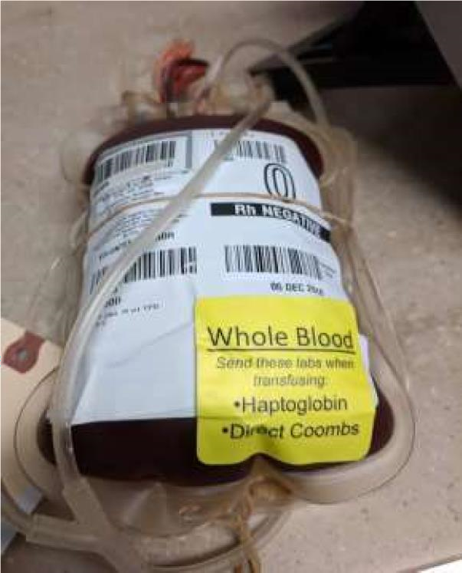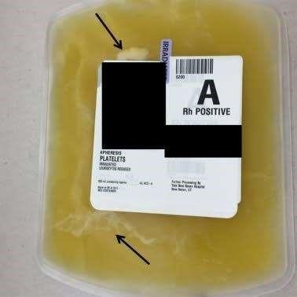

* Fresh frozen plasma:-
* Cryoprecipitate:-

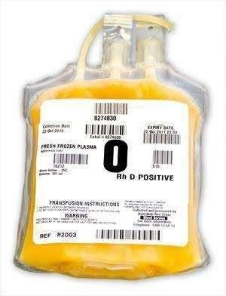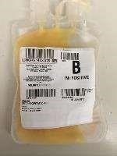

# NURSING ASSESSMENT

* Assess the patient for the indication of the blood transfusion.
* Verify the physicians order for the type of blood product to be given.
* Review the patient’s transfusion history, especially any reactions, or pre transfusion medications to be given.
* Review the baseline vital signs in the patient’s medical record in order to compare with vital signs during the transfusion.
* Assess the type, integrity, and patency of the venous access.
* Verify that a large-bore catheter (18 gauge) has been used to prevent heamolysis.
* Review hospital policy and procedure for the administration of blood products.

**PREPARATION OF EQUIPEMNTS**

* ***A Clean tray containing,***
* Blood administration set with filter
* Intravenous solution of 0.9% sodium chloride (NS)
* Disposable gloves
* Adhesive tape to secure IV line
* Kidney basin
* Medication card as per policy
* Syringe with distilled water or normal saline or heparin flush to flush in case of block in the line.
* Blood product in the container for transfusion along with the compatibility forms and blood details.  Iv pole
* A sterile tray containing emergency medications  Infusion pump if needed.

 Vital signs tray

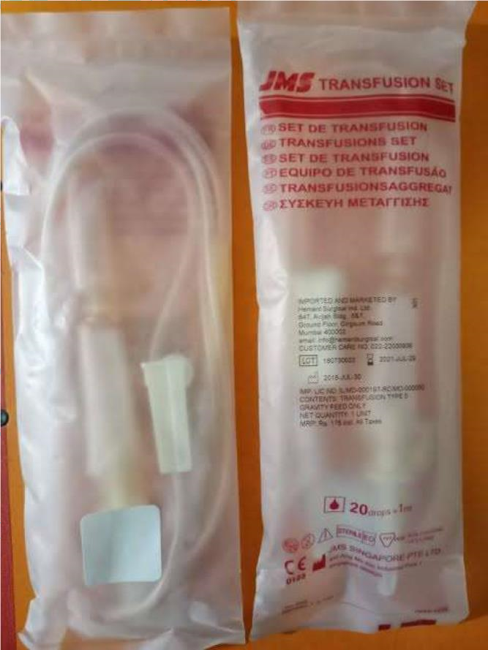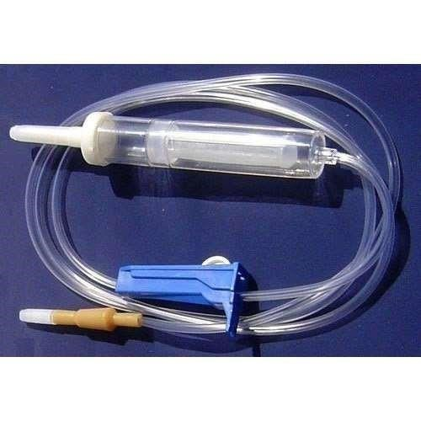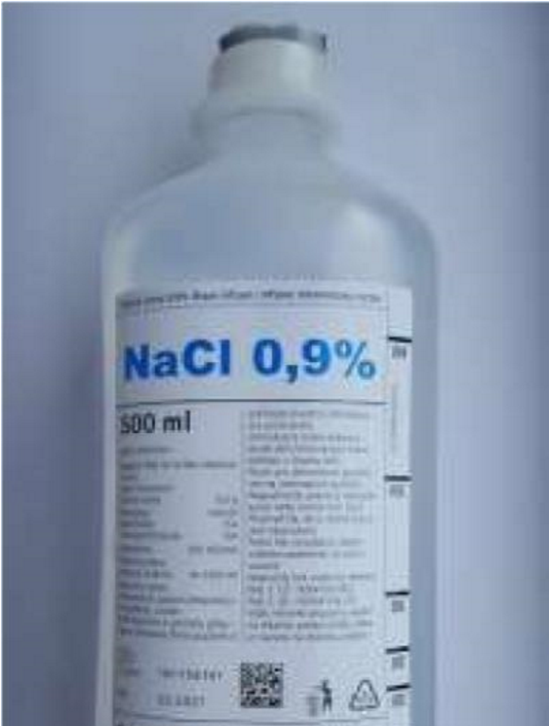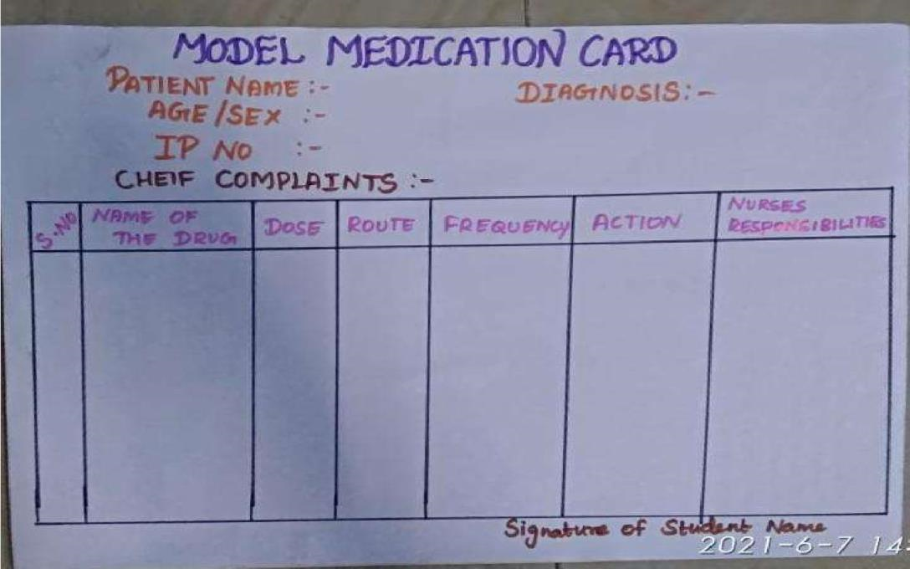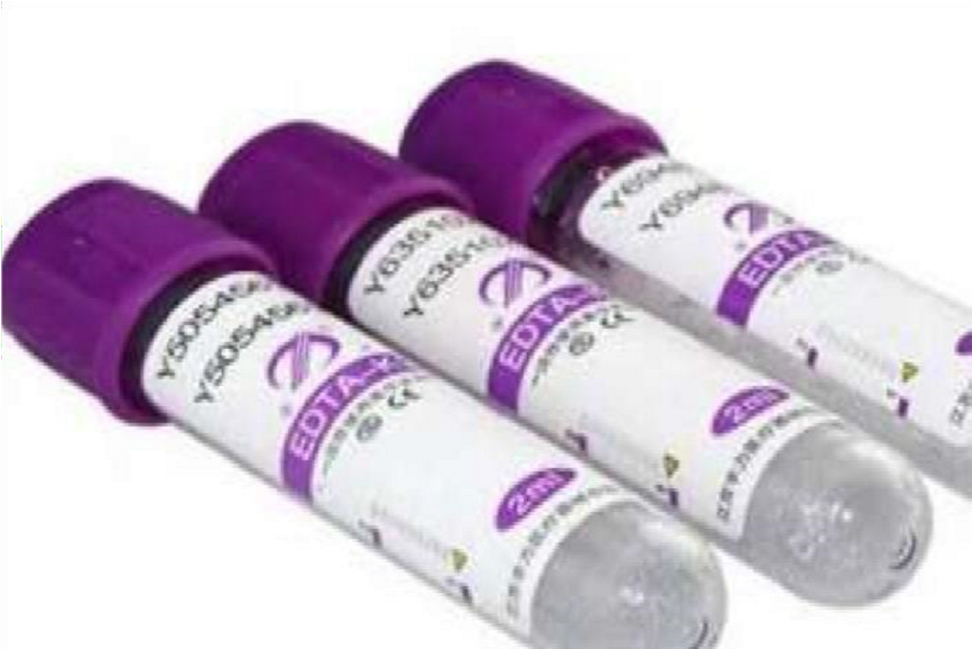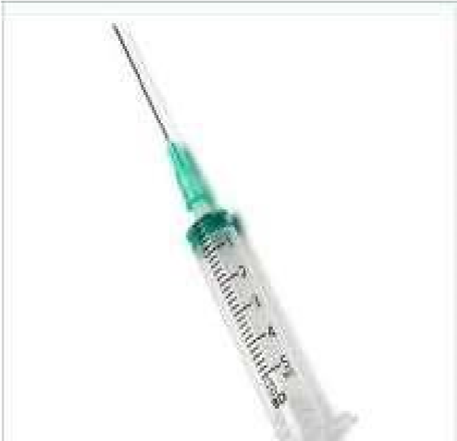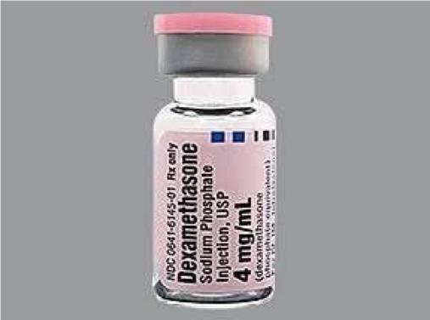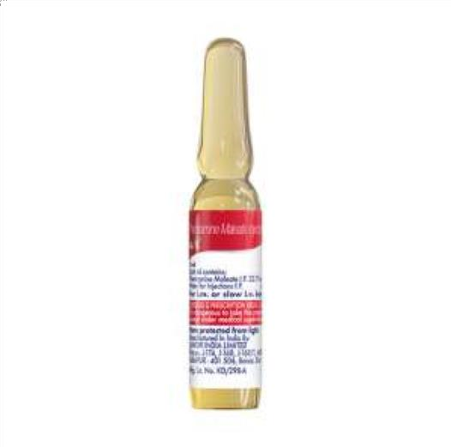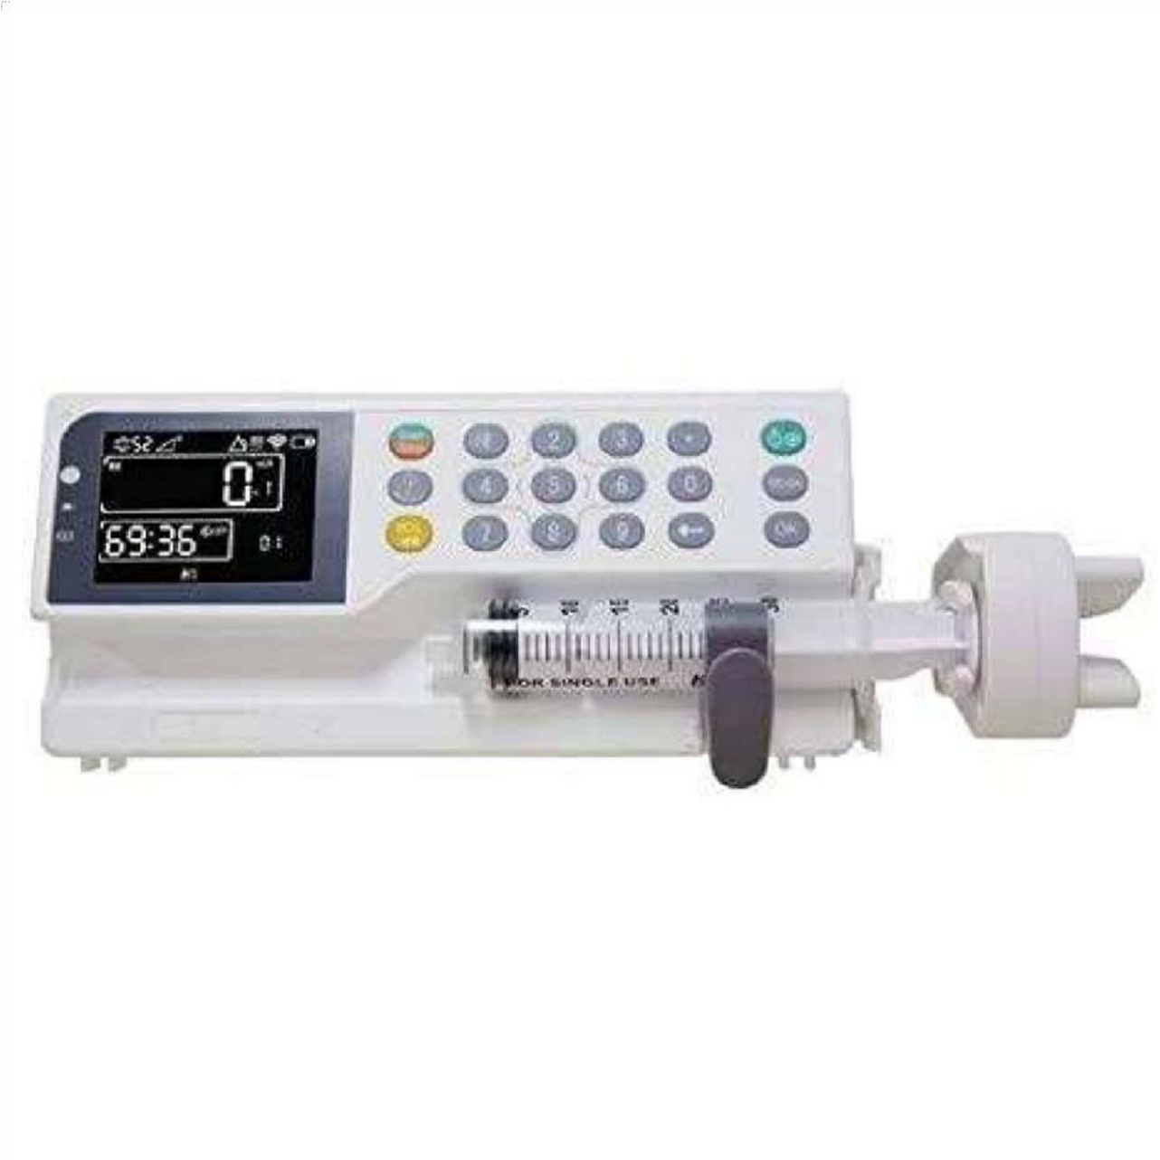

## NURSING PROCEDURE

Verify the physicians order for the transfusion.

Explain the procedure to the patient.

Ensure that the consent forms are signed.

Inform about the side effects (dyspneoa, chills, headache, chest pain, itching) to the patient and ask him/her to report to the nurse.

Obtain baseline vital signs.

Obtain the blood product from the blood bank and ensure that it is initiated within 30 minutes.

Verify and record the blood product and identify the patient with another nurse.

* Patient name, blood group, and Rh type
* Cross – match compatibility

✓Donor blood group and Rh type

✓Unit and hospital number

✓Expiration date and time on blood bag

✓Type of blood product compared with physicians or qualified practitioners order

✓Presence of clots in blood

Instruct the patient to empty the bladder.

Monitor vital signs.

Wash hands and put on gloves.

Open blood administration kit/set and move roller clamps to a closed position and administer prescribed medicines.

***for single- tubing set:***

✓Spike blood unit.

✓Squeeze drip chamber and allow the filter to fill with blood.

✓Open roller clamps and allow tubing to fill with blood to the hub.

✓Prime another IV tubing with normal saline and piggyback it to the blood administration set with a needle and secure all connections with tape.

***For dubble-tubbing set:***

✓Spike the second into the normal saline bag or bottle.

✓Squeeze the drip chamber and allow the filter to fill with normal saline.

Attach tubing to venous catheter using sterile precautions and open lower clamp.

Infuse the blood at a rate of 2-5 ml/min according to the physicians order.

Remain with the patient for the first 15-30 minutes, monitoring vital sighs every 5 minutes for 15 minutes, the every 15 minutes for 1 hour, and then hourly until 1 hour after the infusion is completed.

After the blood has been infused, allow the tubing to clear with normal saline.

Appropriately dispose off bag, tubing and gloves.

Wash hands.

Document the procedure.

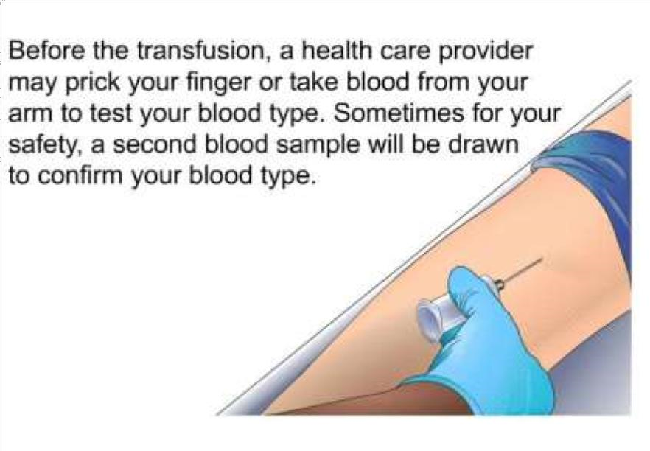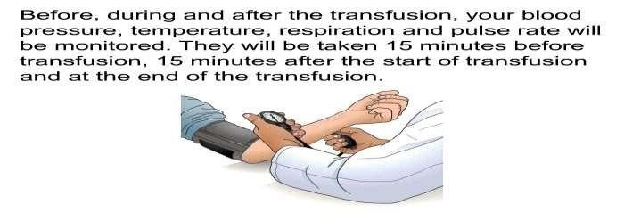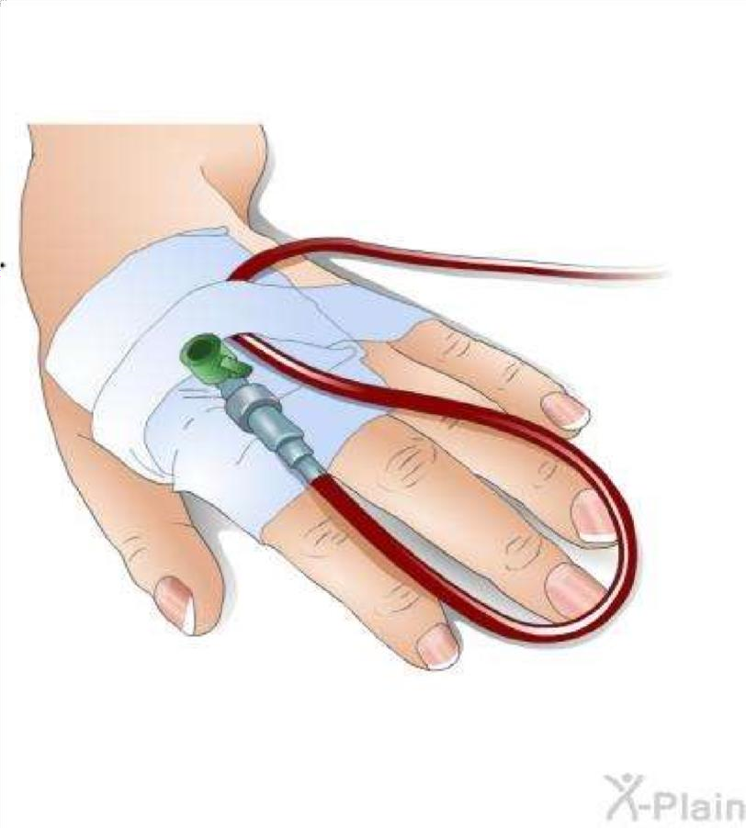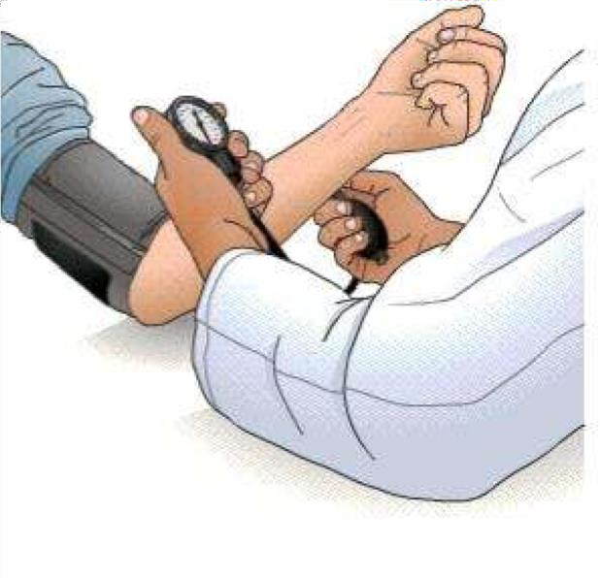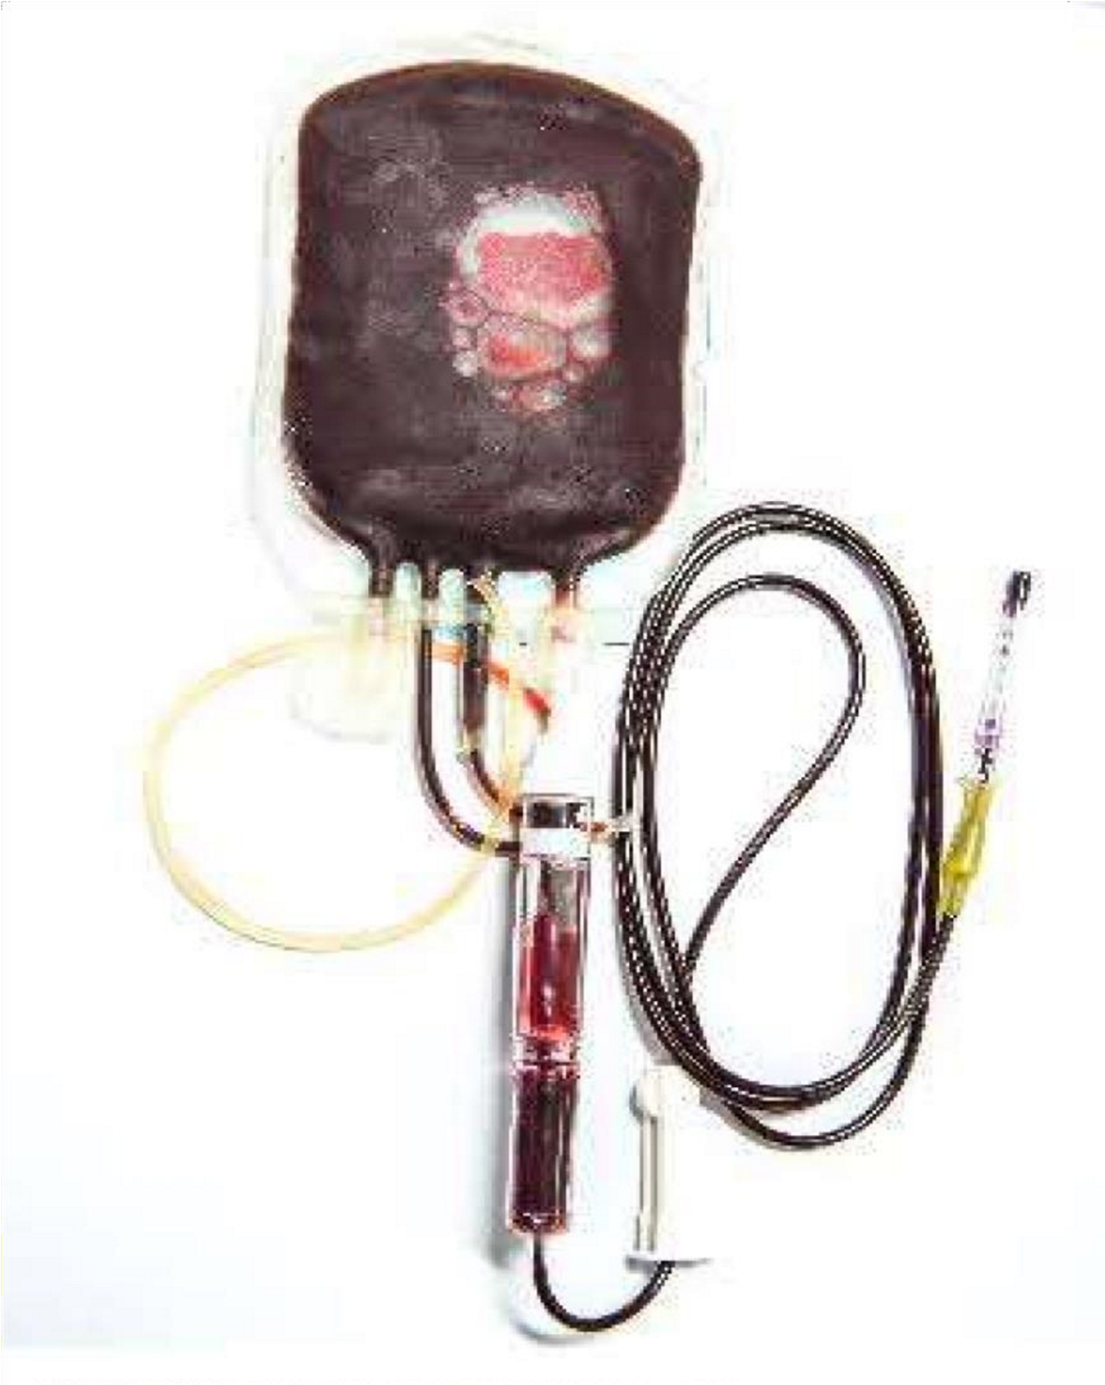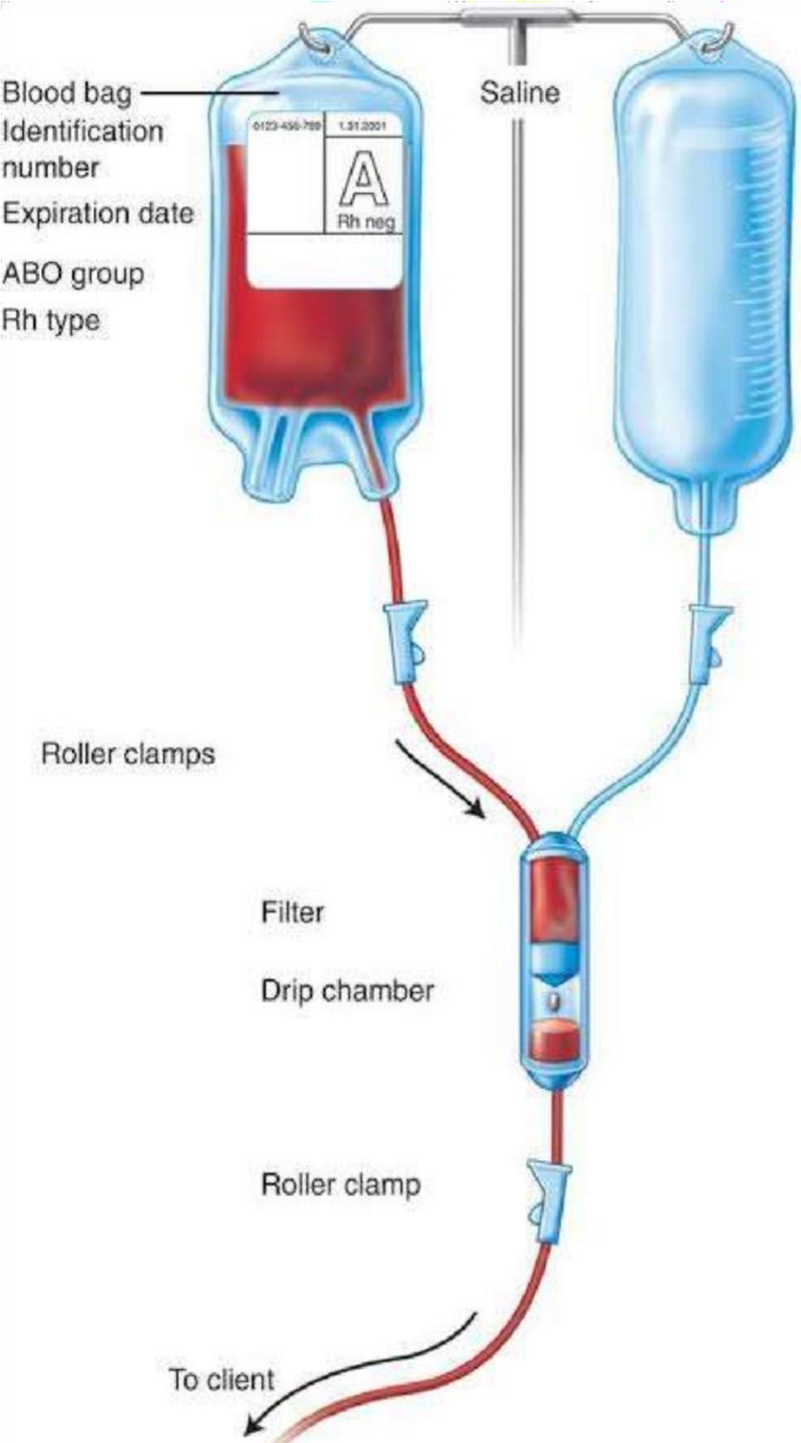

# RECORDING AND REPORTING

* Record the date and time of blood transfusion.
* Mention the details of the transfusion including type of blood, blood group, bag number, starting time, ending time, flow rate, and any adverse reactions during the transfusions.
* Record the vital signs before, during and after the transfusion.

# NURSES RESPONSIBILITES

1. Observe for signs of transfusion reaction.
2. Observe the patient and laboratory values to determine response to transfusion.
3. Monitor IV site and status of infusion each time when vital signs are taken.

**COMPLICATIONS**

|  |  |  |
| --- | --- | --- |
| **COMPLICATIONS** | **SIGNS AND**  **SYMPTOMS** | **NURSES**  **MANAGEMENT** |
| 1. Allergic reactions | Rashes, flushing, hives, pruritis, laryngeal edema, and dyspnea | •Stop the infusion immediately. |
| 2.Nonhemolytic febrile reaction | Sudden chills, fever , flushing, headache and  anxiety | •Keep vein open with the normal saline |
| 3. Septic reaction | Rapid onset of chills, vomiting, hypotension,  and fever | •Notify the physicians immediately |

|  |  |  |
| --- | --- | --- |
| 4. Circulatory overload | Cough, dyspnea,  distended neck veins,  crackles and elevated blood pressure | •Administer antihistamine  parenterally as needed and as per order. |
| 5. Hemolytic reaction | Low back pain,  tachypnea, hypotension |  |

# SAMPLE DOCUMENTATION

* 11.03.2021 , 10.00 am
* Explained the procedure to the patient. Ensured that the consent form was signed. Instructed the patient to empty the bladder. Checked for bag number, grouping and cross-matching.
* After premedication, whole blood (as prescribed) B+ve, bag no.****was transfused to Mr. X at ……am. Vitals were monitored frequently and the patient was observed for transfusion reactions. The transfusion ended at ….pm. Patient felt comfortable.

